**PHYSICAL FITNESS PREDICTION**



A Minor Project Report

in partial fulfillment of the degree

**Bachelor of Technology**

in

**Computer Science & Artificial Intelligence**

**By**

2003A52068 T. Bhavana

**Under the Guidance of**

**Mr. O.Srinivas**

Associate Professor,

**Submitted to**



**SCHOOL OF COMPUTER SCIENCE & ARTIFICIAL INTELLIGENCE**

**SR UNIVERSITY, ANANTHASAGAR, WARANGAL**

**April, 2023.**



**SCHOOL OF COMPUTER SCIENCE & ARTIFICIAL INTELLIGENCE**

**CERTIFICATE**

This is to certify that this project entitled “**PHYSICAL FITNESS PREDICTION**" is the bonafied work carried out by T. Bhavana as a Minor Project for the partial fulfillment to award the degree **BACHELOR OF TECHNOLOGY** in **COMPUTER SCIENCE & ARTIFICIAL INTELLIGENCE** during the academic year 2022-2023 under our guidance and Supervision.

**Mr.O.Srinivas Dr. M.Sheshikala**

Designation, Assoc.Prof.&HOD(CSE), SR University, SR University ,

Ananthasagar, Warangal. Ananthasagar, Warangal.

**ACKNOWLEDGEMENT**

We owe an enormous debt of gratitude toour project guide **Mr.O.Srinivas, Assistant Professor** as well as Head of the CSE Department **Dr. M.Sheshikala, Associate Professor** for guiding us from the beginning through the end of the Minor Project with their intellectual advices and insightful suggestions. We truly value their consistent feedback on our progress, which was always constructive and encouraging and ultimately drove us to the right direction.

We express our thanks to project co-ordinators **Dr.** **P Praveen, Assoc. Prof., and Dr. Mohammed Ali Shaik, Asst. Prof.** for their encouragement and support.

We wish to take this opportunity to express our sincere gratitude and deep sense of respect to our beloved Dean, **Dr. C.V. Guru Rao,** for his continuous support and guidance to complete this project in the institute.

Finally, we express our thanks to all the teaching and non-teaching staff of the department for their suggestions and timely support.

T.Bhavana

**ABSTRACT**

As we Humans give more importance to our Body performance to check our health / Fitness, whether it is in good balance or not. But these days everyone has become very busy with their daily schedules. Even we are busy it is very important to look over the body performance, body performance is different for every one it is dependent on many other aspects like Age, Gender, Height, Weight, Body fat, maximum blood pressure(Diastolic), bottom pressure level(Systolic), Grip force, Muscular strength, daily exercises (like sit and bend, sit ups, broad jumps).​

So, its very important to know performance of body where ever we are, for this we need a model which predicts the fitness of body just by entering our basic data/information, based on the prediction by our ML model we can get an idea on our body in which condition it is in and we can plan to improve if needed, else maintain the same routines.

|  |  |  |  |
| --- | --- | --- | --- |
|  |  | **LIST OF FIGURES** |  |
| **FIGURES NO** |  | **IMAGE NAME** | **PAGE NO** |
| Fig. 1 |  | Use Case Diagram | 03 |
| Fig. 2 |  | Data Flow Diagram | 04 |
| Fig 3 |  | SVM | 04 |
| Fig. 4 |  | Random Forest algorithm | 05 |
| Fig. 5 |  | Decision Tree algorithm | 06 |
| Fig. 6 |  | Data visualization graph | 07 |
| Fig. 7 |  | Decision Tree Result | 08 |
| Fig. 8 |  | Random Forest Result | 09 |
| Fig. 9 |  | SVM Result | 10 |
| Fig. 10 |  | User interface and sample result 1 | 10 |
| Fig. 11 |  | User interface and sample result 2 | ` 11 |

**CONTENTS**

Acknowledgement I

Abstract II

List of figures III

|  |  |  |
| --- | --- | --- |
| **CHAPTER** | **TITLE** | **PAGE NO** |
| **1**. | **Introduction** | **07** |
|  | 1.1 Existing System | 07 |
|  | 1.2 Data visualization using graph | 07 |
| **2.** | **Literature Survey** | **08** |
|  | 2.1 Related Work | 08 |
| **3.** | **Design** | **09** |
|  | 3.1Requirement specifications | 09 |
|  | 3.2 UML Diagram | 10-11 |
| **4.** | **Implementation** | **12** |
| **7.** | 4.1 Overview Technology | 12-22 |
|  | 4.2 Data Visualization using Graphs | 23- 25 |
| **5.** | **Testing** | **26** |
|  | 5.1 Test Cases | 26 |
|  | 5.2 Test Results | 27-38 |
| **6**. | **Results** | **39** |
|  | 6.1 Comparative Results Analysis | 39-41 |
|  | 6.2 User Interface and output | 41-43 |
| **7.** | **Conclusion and Future Scope** | **44** |
|  | 7.1 Conclusion | 44 |
|  | 7.2 Future Scope | 44 |
|  | **Bibliography** | **45** |

**CHAPTER - 1**

**INTRODUCTION**

**1.1 OVERVIEW**

Physical fitness prediction based on daily excerise/workout.​workout: diastolic, systolic, gripForce, sit and bend forward_cm, sit-ups counts, broad jump_cm. Machine Learning algorithms. ​Hight, weight, body fat of human.​To assist fitness of once own body.​For attaining this goal, we use the following steps:​Problem Statement.​Data Set: diastolic ,systolic gripForce, sit and bend forward_cm, sit-ups counts, broad jump_cm .​Pre-Processing; Dividing dataset into train and test datasets and Visualizing.​Applying Random forest , decsion tree , SVM, Algorithms. Flask API for Results

**1.2 PROPOSED SYSTEM**

Physical fitness prediction is a major aspect.​Machine Learning Alogorithm is going predict whether the person need to take care .​Based on some features of a person we are going to predict body performance whether he/she having best performance , satisfied , bad or worst Body performance ​To build the models, we will perform the following steps:​Defining the model: Defining supervised machine learning model​Training the model: Training the models with training and testing dataset of physical fitness.​Evaluate the model​Make predictions: Making custom predictions.​Create a Flask application: Frontend web-app deployment

**CHAPTER – 2**

**LITERATURE SURVEY**

**2.1 RELATED WORK**

Based on some features of a person we are going to predict body performance whether he/she having best performance, satisfied, bad or worst.

​Loading data​: To implement the dataset for the project, data contents from CSV files can be read into the Python environment using the Pandas library into softwares like colab or anaconda.​

Data processing​: from sklearn library we imported preprocessing data and we used label encoder to change the string datatype to 0,1’s (M:0, F:1)​

Data splitting​: Splitting the into training and testing set (X variable, Y variable)​

Model building:​Based on some features of a dataset we are going to implement the multi classification algorithms ​Called logistic regression, KNN, SVM, Naive bayes, Decision tree, Random forest .​

This dataset can be used to illustrate multiple classification algorithms. Accurate measurement of body performance based on some features like Age, gender, height, weight, body fat, diastolic, systolic etc…, is inconvenient/ costly (when we approach the doctor).​

This application help the people to feel more convenient to check their performance of body.​

Tools and techniques: Jupyter notebook, ml model.​

Merits: The whole model demanded much less computational time.

**CHAPTER – 3**

**DESIGN**

**3.1 REQUIREMENT SPECIFICATION (S/W & H/W)**

**Hardware Requirements**

* **System** : Pentium 4, Intel Core i3, i5, i7 and 2GHz Minimum
* **RAM** : 4GB or above
* **Hard Disk** : 10GB or above
* **Input**  : Keyboard and Mouse
* **Output** : Monitor or PC

**Software Requirements**

* **OS** : Windows 8 or Higher Versions
* **Platform** : Pycharm / Jupyter Notebook/ colab
* **Program Language** : Python ,HTML

**3.2 UML DIAGRAMS USE CASE DIAGRAM**

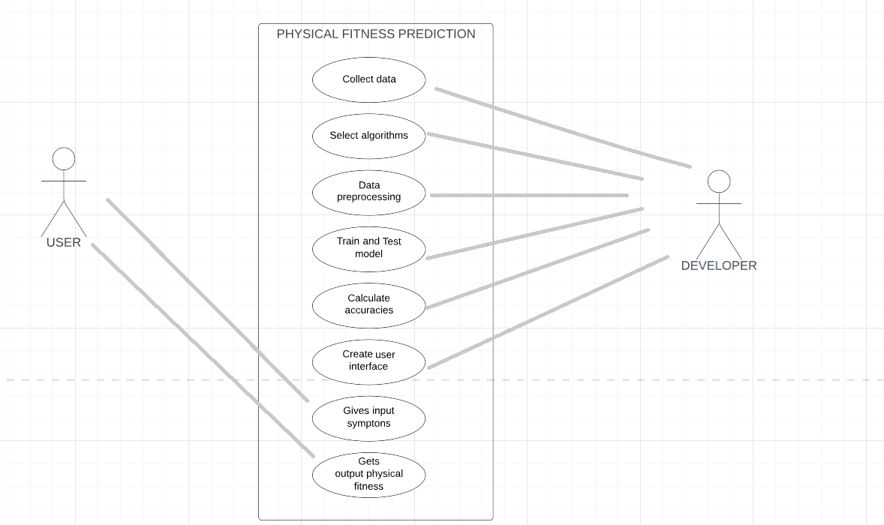

**Fig.1** Use case diagram Physical fitness using workout Prediction

Physical fitness prediction with rate of work out.

**User**: Going to interact by filling the details which is available on the web page.

**Mode**l: To predict the output/outcome with the help of training and testing the suitable model.

**Developer**: Model building and connecting the user interface is done by the developer.

User side page is developer using HTML and CSS.

Model is implemented using Python.

**DATA FLOW DIAGRAM**

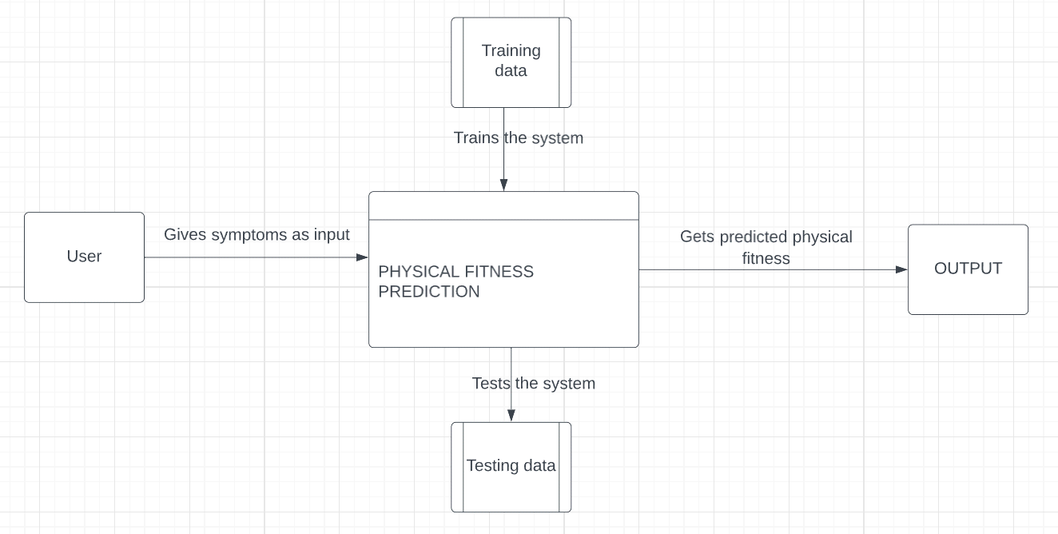

**Fig.2** Dataflow diagram fitness rate with workout Prediction

**CHAPTER – 4**

**IMPLEMENTATION**

**4.1. OVERVIEW TECHNOLOGY**

**Data set**

**Body performance with workout dataset in .csv format**

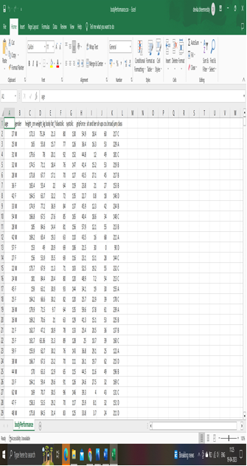

**ATTRIBUTES (INDEPENDENT VARIABLES)**

Considering X as individual variable:

X1, X2, X3, X4, X5, X6…………..,X11

Age

Gender

Height_cm

Weight

Body fat%

Diastolic

Systolic

Gripforce

Sit and bend

Sit-up counts

Broard jump

**Labels (Dependent variables)**

Considering as y which is the dependent variable on x variables

Class: A, B, C, D

Prediction can be Y’

**Support Vector Machine Algorithm**

Support Vector Machine is the one of the most popular supervise learning

algorithms, which is use for classification as well as regression problem.

However, primarily, it is used for classification problems in machine learning.

The goal of the SVM algorithm is to create the best line or decision boundary that can

segregate n-dimensional space into classes so that we can easily put the new data point

in the correct category in the future. This best decision boundary is called a

hyperplane. SVM chooses the extreme points/vectors that help in creating the

hyperplane. These extreme cases are called as support vectors, and hence algorithm is

termed as Support Vector Machine.

**Formula**

F(x) = sum(n) = 1N(an-an*)(xn’x)+b

SVM Error = Margin Error + Classification Error.

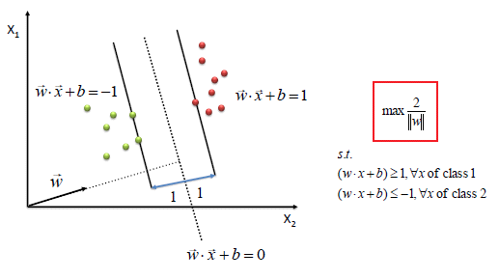

Support vector machine

Code implementation of SVM in colab

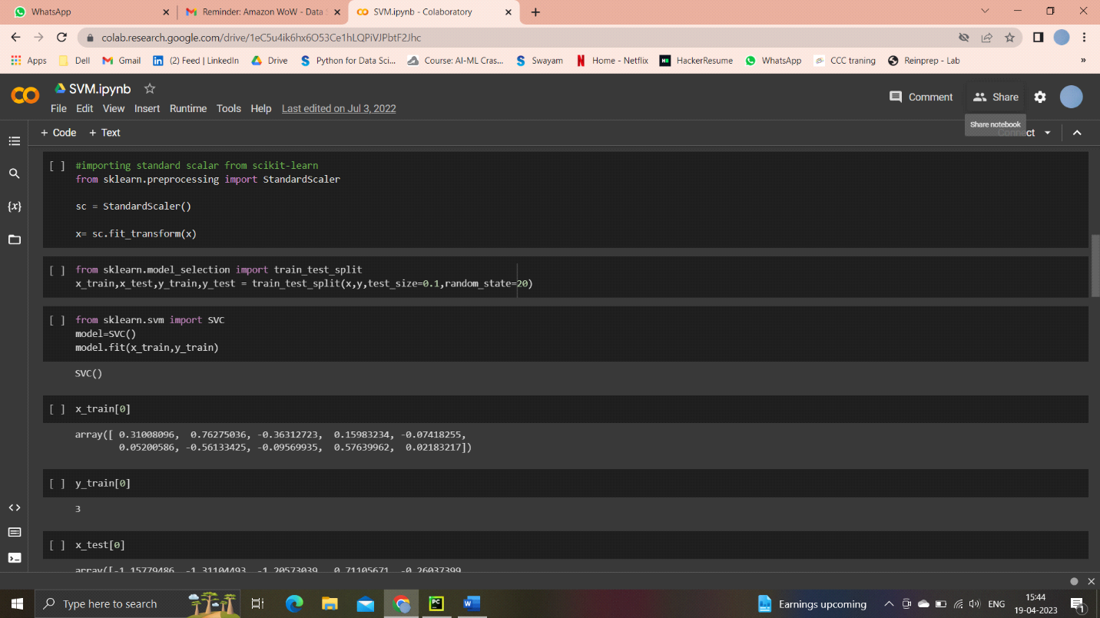

(Training and Testing the model)

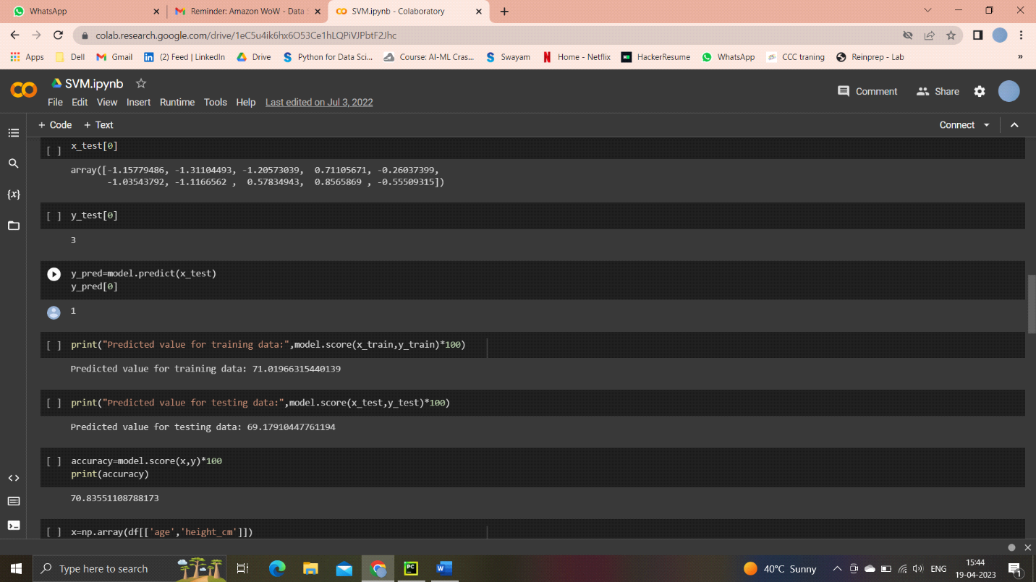

(Accuracy)

**Visualizing**

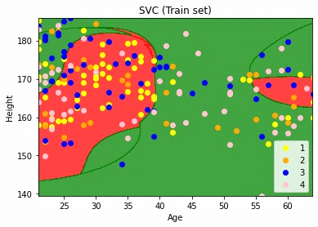

Support vector machine (Training set)

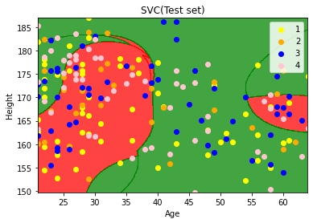

**Fig. 4** Support Vector Machine algorithm

**Random Forest Algorithm**

Random Forest is a popular machine learning algorithm that belongs to the supervised learning technique. It can be used for both Classification and Regression problems in ML. It is based on the concept of ensemble learning, which is a process of combining multiple classifiers to solve a complex problem and to improve the performance of the model.

As the name suggests, "Random Forest is a classifier that contains a number of decision trees on various subsets of the given dataset and takes the average to improve the predictive accuracy of that dataset." Instead of relying on one decision tree, the random forest takes the prediction from each tree and based on the majority votes of predictions, and it predicts the final output.

The greater number of trees in the forest leads to higher accuracy and prevents the problem of overfitting.

The below diagram explains the working of the Random Forest algorithm:

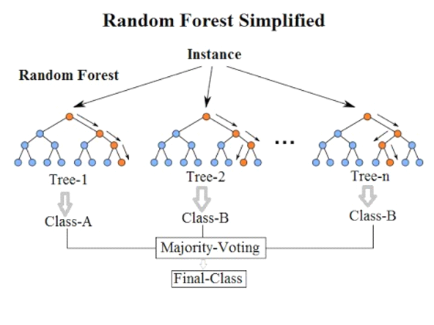

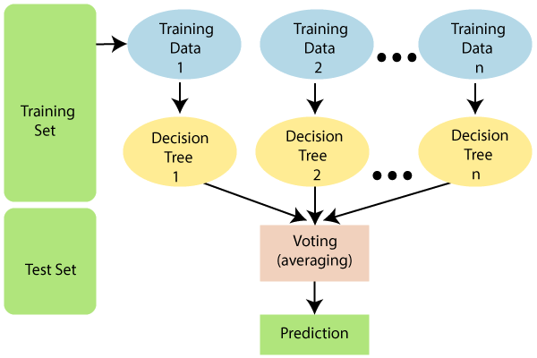

**Fig .5** Random Forest algorithm

Below are some points that explain why we should use the Random Forest algorithm: o It takes less training time as compared to other algorithms.

o It predicts output with high accuracy, even for the large dataset it runs efficiently. o It can also maintain accuracy when a large proportion of data is missing.

**Decision Tree Classification Algorithm**

Decision Tree is a Supervised learning technique that can be used for both classification and Regression problems, but mostly it is preferred for solving Classification problems. It is a tree-structured classifier, where internal nodes represent the features of a dataset, branches represent the decision rules and each leaf node represents the outcome.

* In a Decision tree, there are two nodes, which are the Decision Node and Leaf Node. Decision nodes are used to make any decision and have multiple branches, whereas Leaf nodes are the output of those decisions and do not contain any further branches.
* The decisions or the test are performed on the basis of features of the given dataset.
* It is a graphical representation for getting all the possible solutions to a problem/decision based on given conditions.
* It is called a decision tree because, similar to a tree, it starts with the root node, which expands on further branches and constructs a tree-like structure.
* In order to build a tree, we use the CART algorithm, which stands for Classification and Regression Tree algorithm.
* A decision tree simply asks a question, and based on the answer (Yes/No), it further split the tree into subtrees.

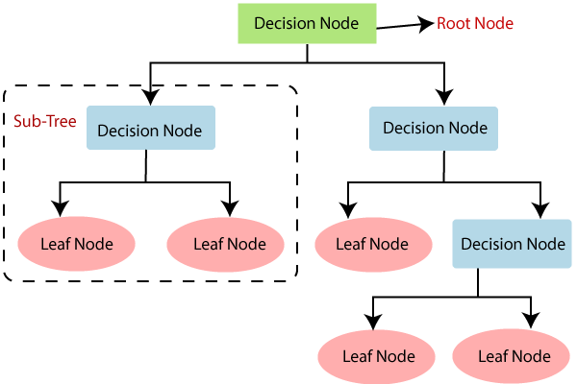

**Fig.6** Decision Tree algorithm

**Code implementation of decision tree in colab**

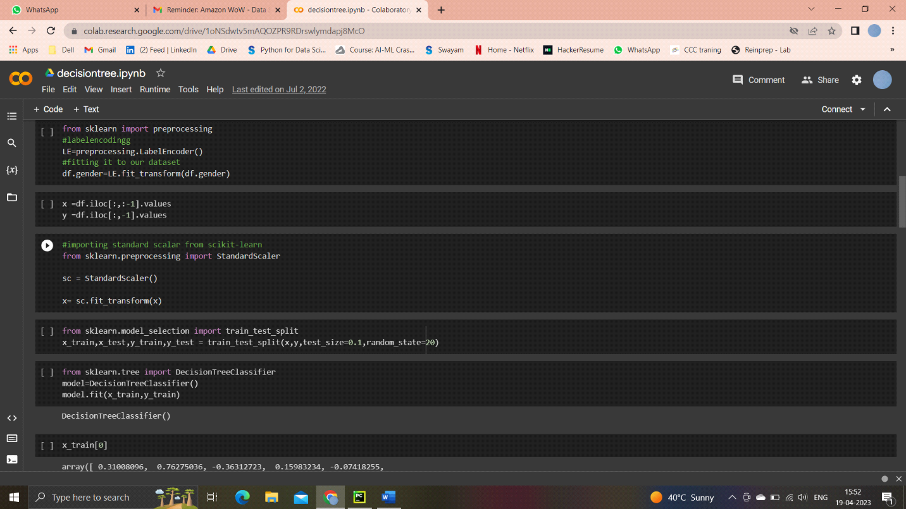

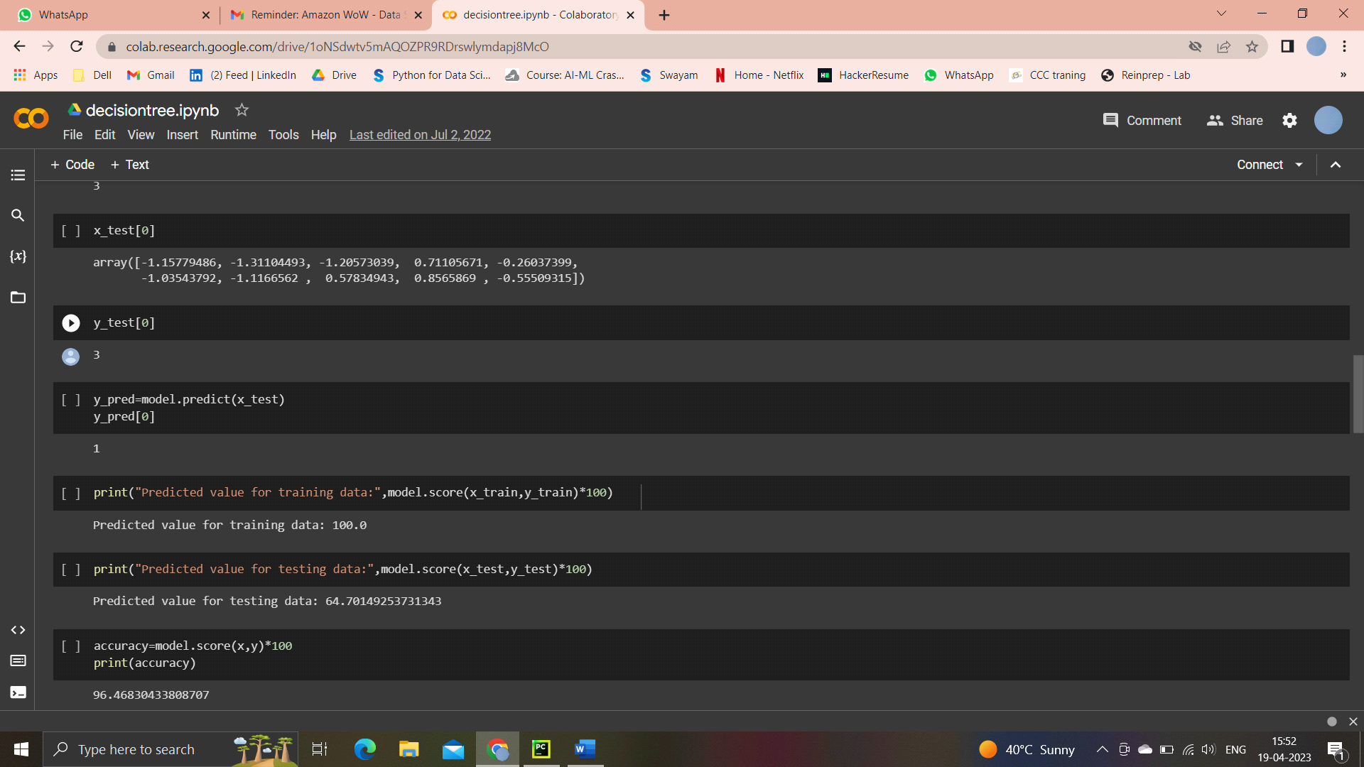

Data Visualizing

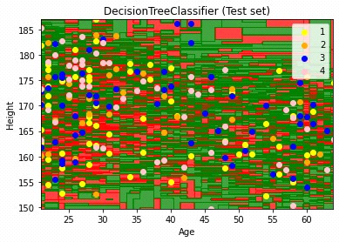

**4.2 DATA VISUALIZATION USING GRAPH**

In order to understand the data more deeply we have used histograms to analyze the image data . In the Figure we have shown the histograms for all datasets. Through this we can understand the data more efficiently.

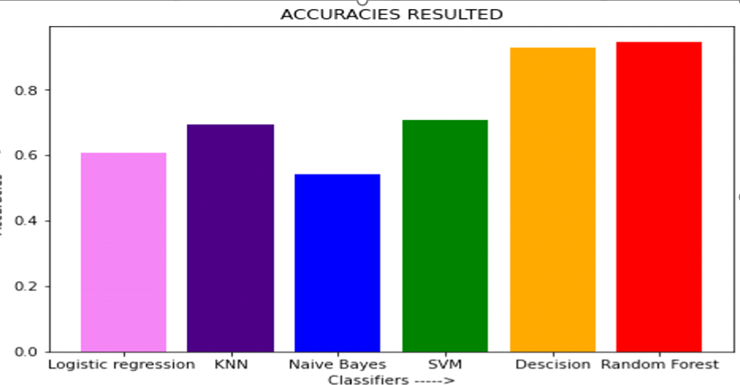

**Fig. 7** Data visualization graph



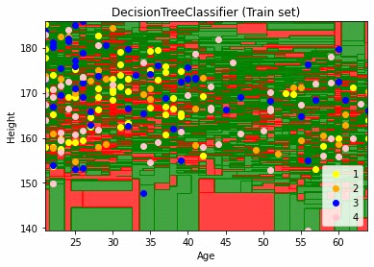

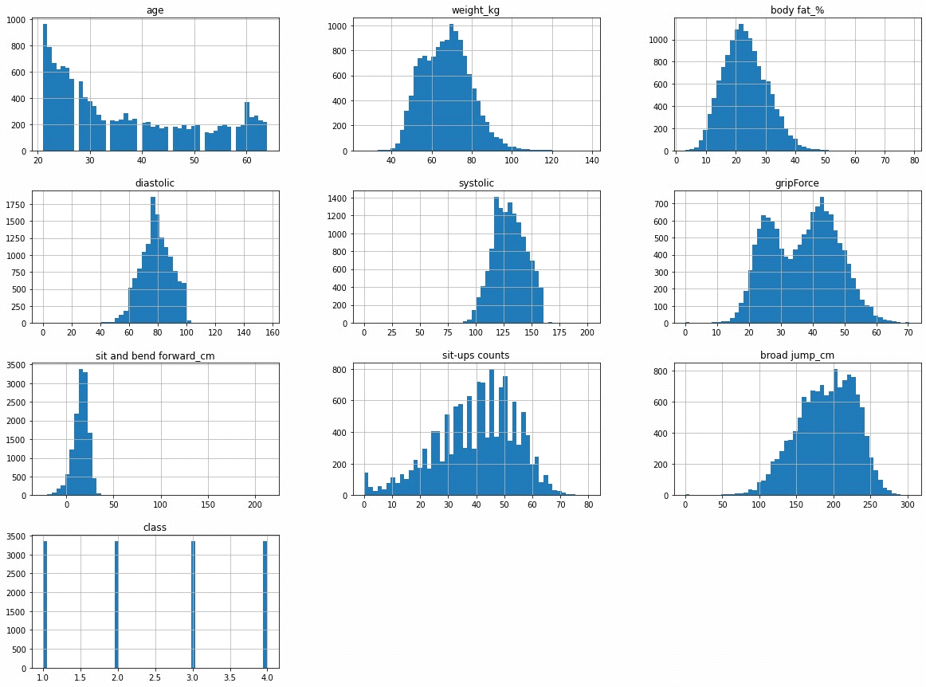

**CHAPTER – 5 TESTING**

**5.1.TEST CASES**

* User gives an input as 11, according to it Body performance according to workout are predicted using Decision

Tree, Random Forest, Support vector machine algorithms.

* Testing accuracy for these algorithm are Decision Tree:96% ,Random Forest:91.9%,Support Vector Machine Algorithm:70
* Total columns 11 are rows are

**5.2.TEST RESULTS**

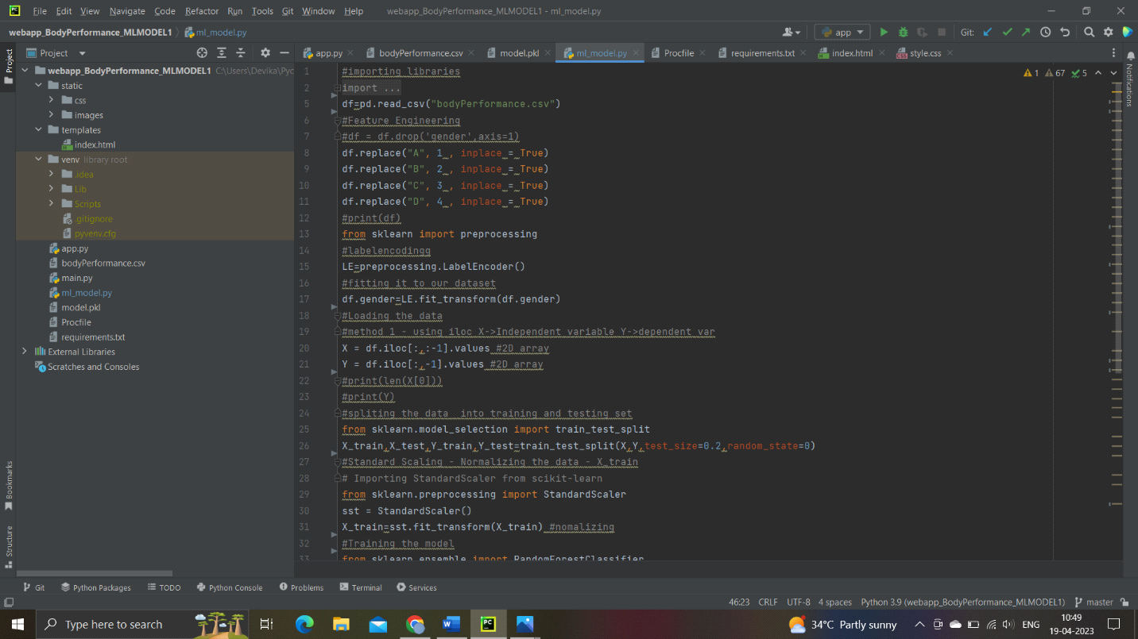

**ML_model.py-1**

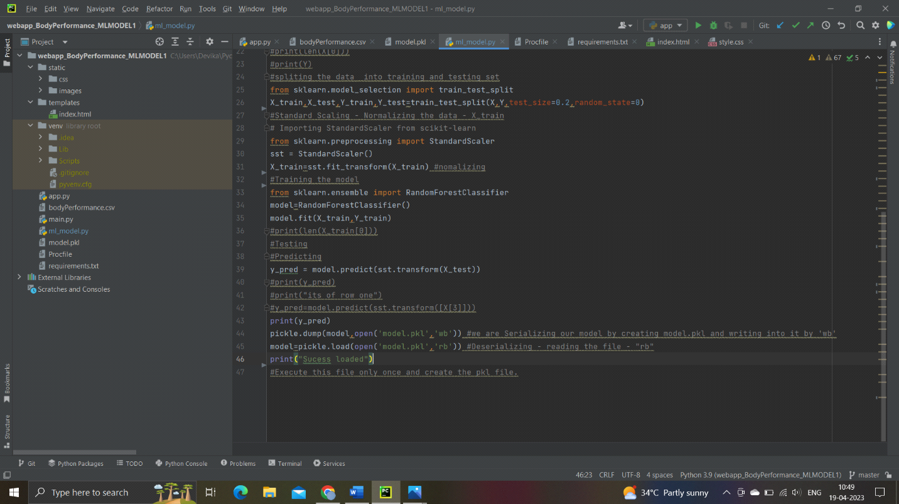

**ML_model.py-2**

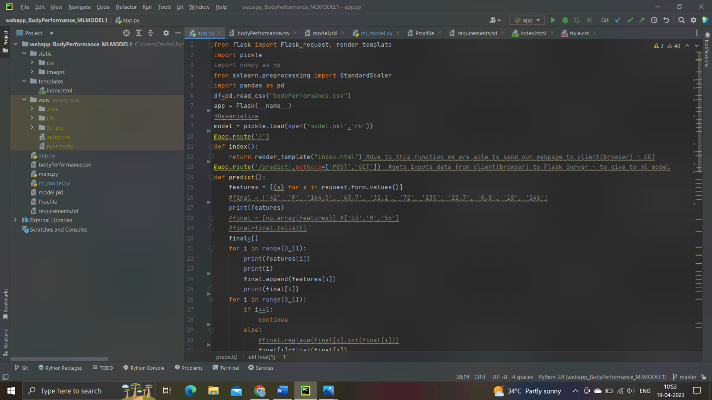

**App.py-1**

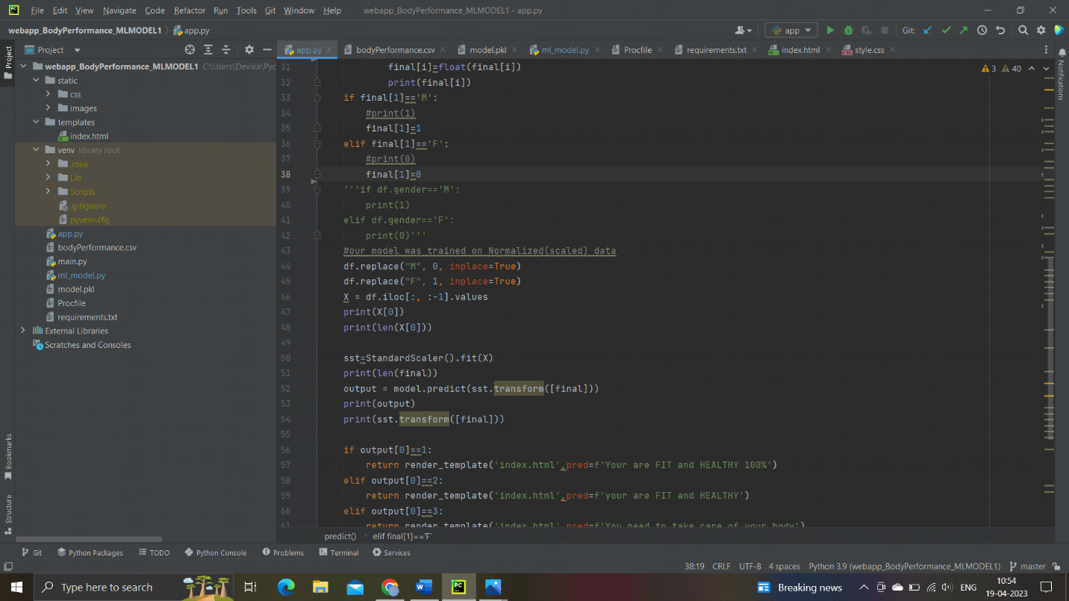

**App.py-2**

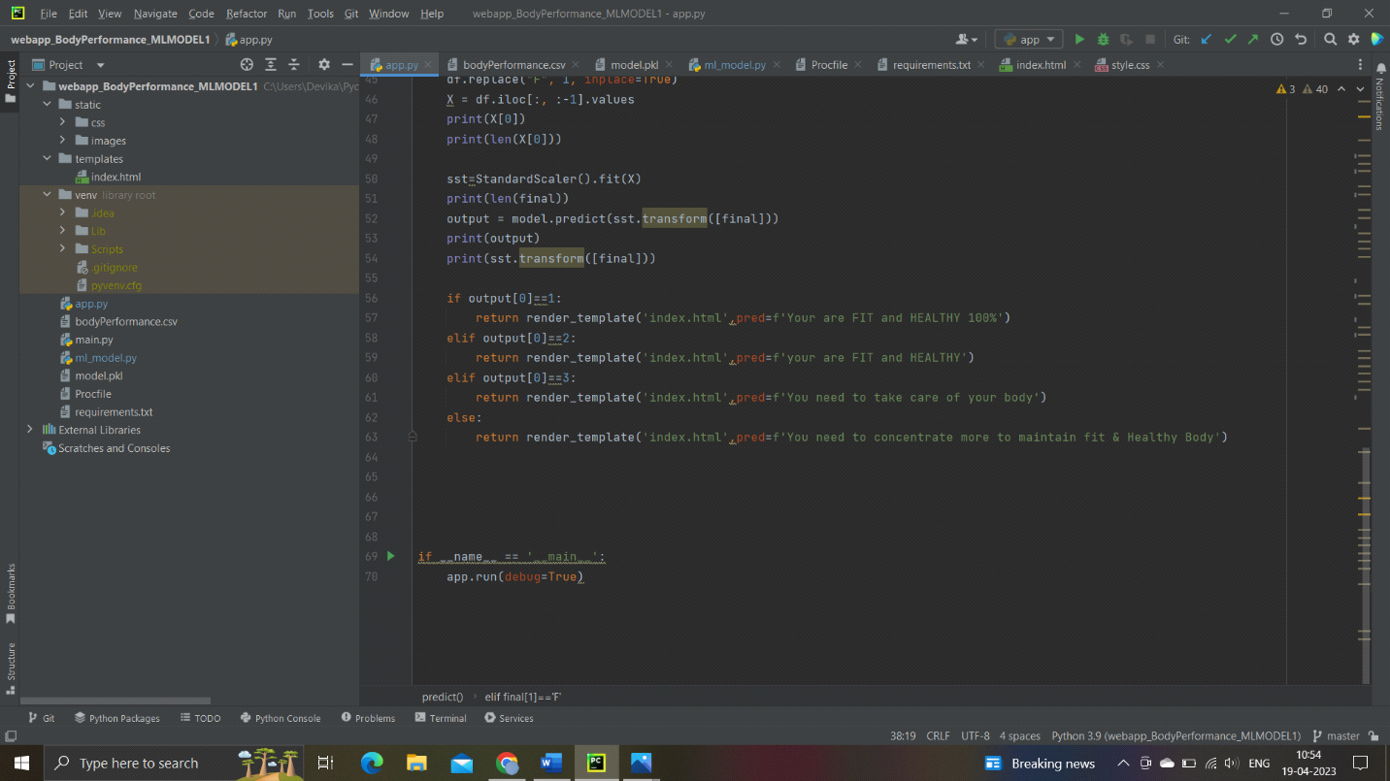

**App.py-3**

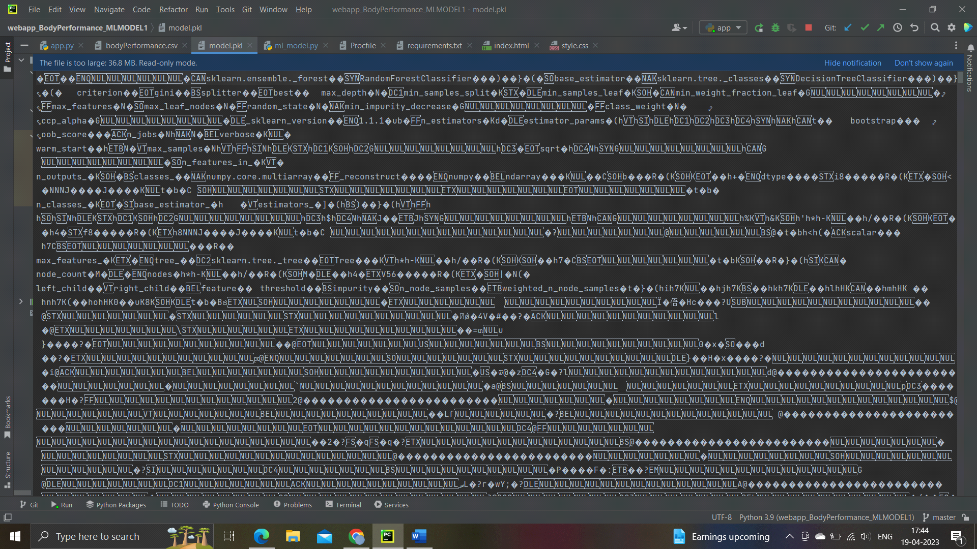

Model.Pkl file where the converted code is available.

Which helps us to run/work the model even the source file is lost.

Need to write in procfile

web: gunicorn app:app

Requriments.TXT file

gunicorn==20.1.0  
numpy==1.23.0  
pandas==1.4.3  
python-dateutil==2.8.2  
pytz==2022.1  
six==1.16.0  
Flask==2.1.2  
sklearn==0.0

which is installing some of the packages need to build our web application.

**gunicorn**:

gunicorn is a pure python wsgi server with simple configuration and multiple

Worker implementation for performance tuning.

**numpy**:

Numpy brings the computational power of languages like c … to python,

A language much easier to learn and use.

**Pandas**:

Pandas is a fast, powerful, flexible and easy to use open source data

analysis and manipulation tool built on top of the programming language.

**HTML Code**

<!DOCTYPE html>  
<html>  
<head>  
<link rel="stylesheet" href="../static/css/style.css">  
</head>  
<div id="contact-form">  
 <div>  
 <h1>BODY PERFORMANCE BY WORKOUT</h1>  
 <h4><marquee speed="80">WORKOUT PERFORMANCE</marquee></h4>  
 </div>  
  
  
 <form action='./predict' method="post">  
 <div>  
 <label for="age">  
 <span class="required">AGE: *</span>  
 <input type="number" id="age" name="age" value="" placeholder="Your age.." required="required" tabindex="1" autofocus="autofocus" />  
 </label>  
 </div>  
 <div class="gender">  
 <label for="gender">  
 <span class="required">Gender: *</span></label>  
 <br>  
 <select name="gender" value="gender" id="gender">  
 <!--<option value="" disabled selected hidden>Select</option>-->  
 <option value="M" >Male</option>  
 <option value="F">Female</option>  
 </select>  
  
 </div>  
 <div>  
 <label for="height_cm">  
 <span class="required">Height(cm): *</span>  
 <input type="number" name="height_cm" placeholder="Enter your height(cm)" min="140" max="200" step="0.1" required="required" tabindex="1" autofocus="autofocus" />  
 </label>  
 </div>  
  
 <div>  
 <label for="weight_kg">  
 <span class="required">Weight(kg): *</span>  
 <input type="number" name="weight_kg" placeholder="Enter your Weight(kg)" min="30" max="150" step="0.1" required="required" tabindex="1" autofocus="autofocus" />  
 </label>  
 </div>  
  
 <div>  
 <label for="body fat_%">  
 <span class="required">Body fat%: *</span>  
 <input type="number" name="body fat_%" placeholder="Your body fat %" min="0" max="50" step="0.1" required="required" tabindex="1" autofocus="autofocus" />  
 </label>  
 </div>  
  
 <div>

<label for="diastolic">  
 <span class="required">Diastolic: *</span>  
 <input type="number" name="diastolic" placeholder="Your diastolic" min="40" max="100" step="1" required="required" tabindex="1" autofocus="autofocus" />  
 </label>

</div>

<div>  
 <label for="systolic">  
 <span class="required">Systolic: *</span>  
 <input type="number" name="systolic" placeholder="Your systolic" min="80" max="" step="1" required="required" tabindex="1" autofocus="autofocus" />  
 </label>  
 </div>  
  
 <div>  
 <label for="gripForce">  
 <span class="required">gripForce: *</span>  
 <input type="number" name="gripForce" placeholder="Enter gripForce" min="0" max="100" step="0.1" required="required" tabindex="1" autofocus="autofocus" />  
 </label>  
 </div>  
  
 <div>  
 <label for="sit and bend forward_cm">  
 <span class="required">sit and bend forward_cm: *</span>  
 <input type="number" name="sit and bend forward_cm" placeholder="Enter sit and bend forward_cm" min="-50" max="50" step="0.1" required="required" tabindex="1" autofocus="autofocus" />  
 </label>  
 </div>  
  
 <div>  
 <label for="sit-ups counts">  
 <span class="required">Sit-ups counts: *</span>  
 <input type="number" name="sit-ups counts" placeholder="Enter sit-ups counts" min="0" max="150" step="1" required="required" tabindex="1" autofocus="autofocus" />  
 </label>  
 </div>  
  
 <div>

<label for="broad jump_cm">  
 <span class="required">Broad jump_cm: *</span>  
 <input type="number" name="Broad jump_cm" placeholder="Enter broad jump_cm" min="30" max="400" step="0.1" required="required" tabindex="1" autofocus="autofocus" />  
 </label>

</div>  
  
 <div>  
 <button name="submit" type="submit" id="submit" >SUBMIT</button>  
 </div>  
  
  
 <div>  
 <button name="reset" type="reset" id="reset" >RESET</button>  
 </div>  
 <div>  
 <h3>Grade : {{pred}}</h3>  
 </div>  
 </form>  
  
 </div>  
  
</html>

CSS Code

html{  
 background:url('../images/bodyfitness.jpg')no-repeat;  
 background-size: cover;  
 height:100%;  
 background-color: #000;  
 background-attachment:fixed;  
}  
* {  
 box-sizing:border-box;  
 -webkit-box-sizing:border-box;  
 -moz-box-sizing:border-box;  
 -webkit-font-smoothing:antialiased;  
 -moz-font-smoothing:antialiased;  
 -o-font-smoothing:antialiased;  
 font-smoothing:antialiased;  
 text-rendering:optimizeLegibility;  
}  
body {  
 color: #C0C0C0;  
 font-family: Arial, san-serif;  
}  
  
  
/* Contact Form Styles */  
h1 {  
 margin: 10px 0 0 0;  
}  
h4{  
 margin: 0 0 20px 0;  
}  
#contact-form {  
 background-color:rgba(72,72,72,0.9);  
 padding: 10px 20px 30px 20px;  
 max-width:100%;  
 float: left;  
 left: 50%;  
 position: absolute;  
 margin-top:30px;  
 margin-left: -260px;  
 border-radius:7px;  
 -webkit-border-radius:7px;  
 -moz-border-radius:7px;  
}  
#contact-form input,  
  
  
#contact-form label {  
 font-size: 15px;  
 margin-bottom: 2px;  
 font-family: Arial, san-serif;  
}  
#contact-form input,  
#contact-form select  
 {  
 width:100%;  
 background: #fff;  
 border: 0;  
 -moz-border-radius: 4px;  
 -webkit-border-radius: 4px;  
 border-radius: 4px;  
 margin-bottom: 25px;  
 padding: 5px;  
}  
  
  
  
  
#contact-form input:focus  
  
 {  
 background-color: #E5E6E7;  
}  
  
#contact-form button[type="submit"] {  
 cursor:pointer;  
 width:100%;  
 border:none;  
 background:#991D57;  
 background-image:linear-gradient(bottom, #8C1C50 0%, #991D57 52%);  
 background-image:-moz-linear-gradient(bottom, #8C1C50 0%, #991D57 52%);  
 background-image:-webkit-linear-gradient(bottom, #8C1C50 0%, #991D57 52%);  
 color:#FFF;  
 margin:0 0 5px;  
 padding:10px;  
 border-radius:5px;  
}  
#contact-form button[type="submit"]:hover {  
 background-image:linear-gradient(bottom, #9C215A 0%, #A82767 52%);  
 background-image:-moz-linear-gradient(bottom, #9C215A 0%, #A82767 52%);  
 background-image:-webkit-linear-gradient(bottom, #9C215A 0%, #A82767 52%);  
 -webkit-transition:background 0.3s ease-in-out;  
 -moz-transition:background 0.3s ease-in-out;  
 transition:background-color 0.3s ease-in-out;  
}  
#contact-form button[type="submit"]:active {  
 box-shadow:inset 0 1px 3px rgba(0,0,0,0.5);  
}  
  
  
  
  
#contact-form button[type="reset"] {  
 cursor:pointer;  
 width:100%;  
 border:none;  
 background:#991D57;  
  
  
 background-image:linear-gradient(bottom, #348F0B 0%, #39A811 52%);  
 background-image:-moz-linear-gradient(bottom, #348F0B 0%, #39A811 52%);  
 background-image:-webkit-linear-gradient(bottom, #348F0B 0%, #39A811 52%);  
  
  
  
 color:#FFF;  
 margin:0 0 5px;  
 padding:10px;  
 border-radius:5px;  
}  
#contact-form button[type="reset"]:hover {  
 background-image:linear-gradient(bottom, #15B50C 0%, #1CED10 52%);  
 background-image:-moz-linear-gradient(bottom, #15B50C 0%, #1CED10 52%);  
 background-image:-webkit-linear-gradient(bottom, #15B50C 0%, #1CED10 52%);  
 -webkit-transition:background 0.3s ease-in-out;  
 -moz-transition:background 0.3s ease-in-out;  
 transition:background-color 0.3s ease-in-out;  
}  
#contact-form button[type="reset"]:active {  
 box-shadow:inset 0 1px 3px rgba(0,0,0,0.5);  
}  
  
  
  
  
h3{  
 margin: 10px 0 0 0;  
 color : #6AFFE0  
}  
  
input:required, textarea:required {  
 box-shadow: none;  
 -moz-box-shadow: none;  
 -webkit-box-shadow: none;  
 -o-box-shadow: none;  
}  
#contact-form .required {  
 font-weight:bold;  
 color: #E5E6E7;  
}  
  
/* Hide success/failure message  
 (especially since the php is missing) */  
#failure, #success {  
 color: #6EA070;  
 display:none;  
}  
  
/* Make form look nice on smaller screens */  
@media only screen and (max-width: 580px) {  
 #contact-form{  
 left: 3%;  
 margin-right: 3%;  
 width: 88%;  
 margin-left: 0;  
 padding-left: 3%;  
 padding-right: 3%;  
 }

**CHAPTER – 6 RESULTS**

**6.1 COMPARATIVE RESULTS ANALYSIS**

|  |  |
| --- | --- |
| **Algorithm** | **Testing Accuracy** |
| **Decision Tree** | 96% |
| **Random Forest** | 91.9% |
| **SVM** | 70% |

**Table 1** Comparative results

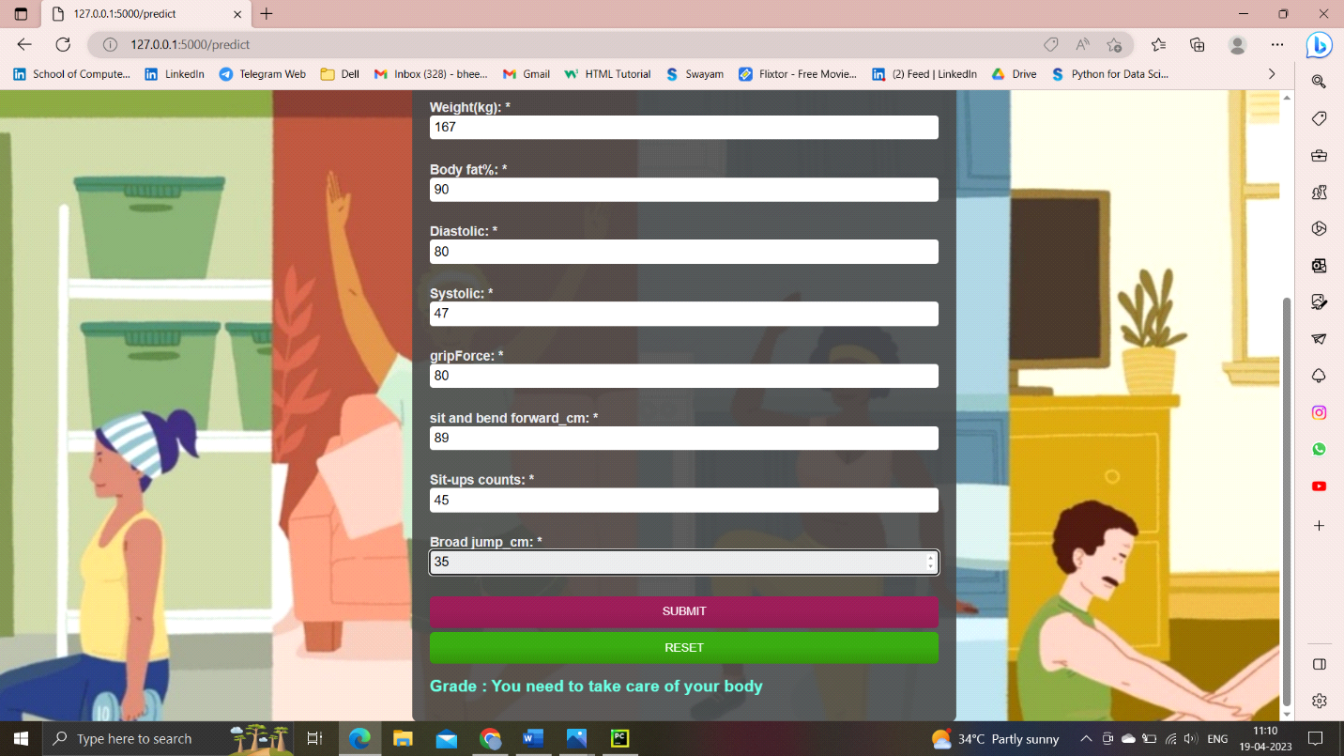

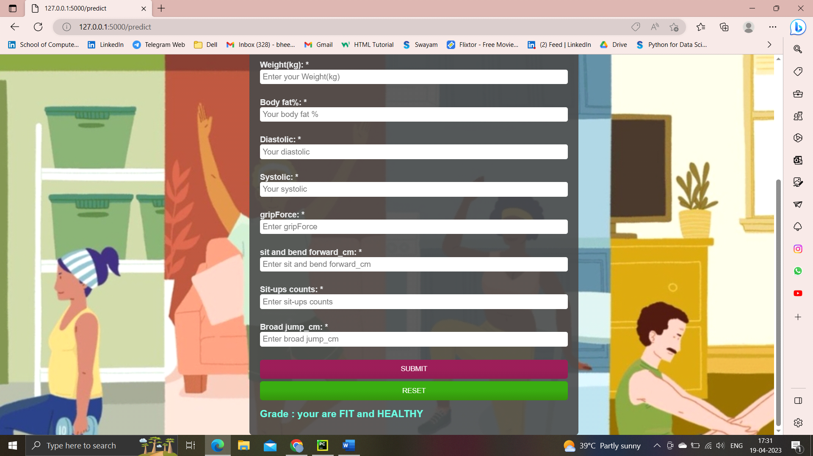

Output Depends on

Based on the input given to the page prediction value will be going to change

There are different segments to which the output is going to depend

As the input values changes the grade is going to change

Output/Grade:

Prediction

Your are FIT and HEALTY 100%

Your are FIT and HEALTHY

You need to take care of your body

You need to concentrate more to maintain fit

**6. 2 USER INTERFACE AND OUTPUT**

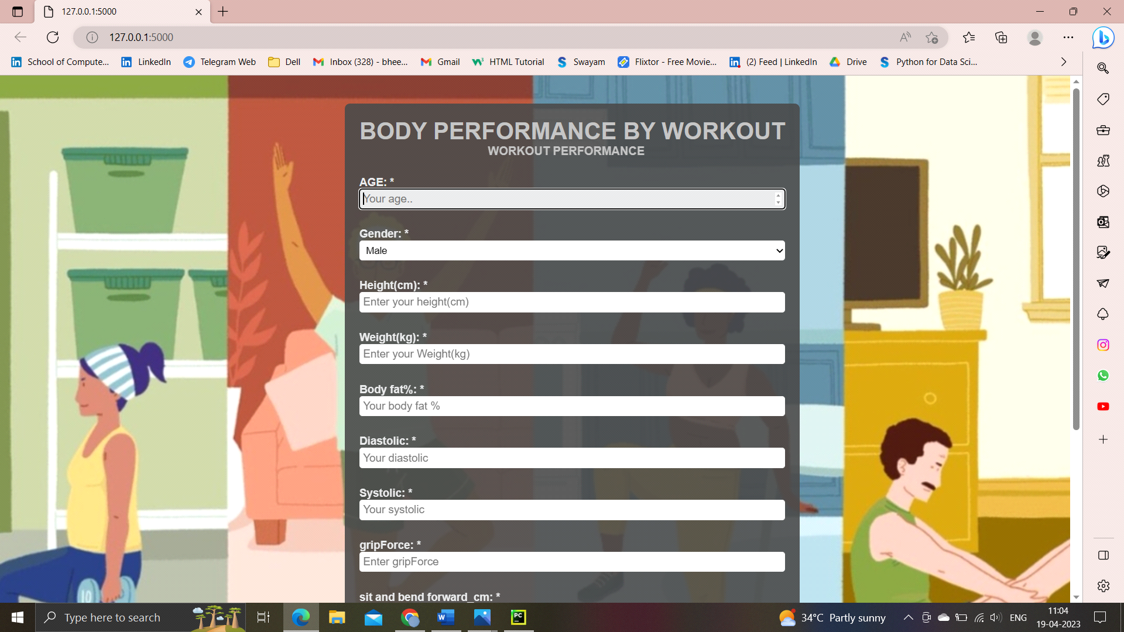

**Fig. 11** User interface and sample result 1

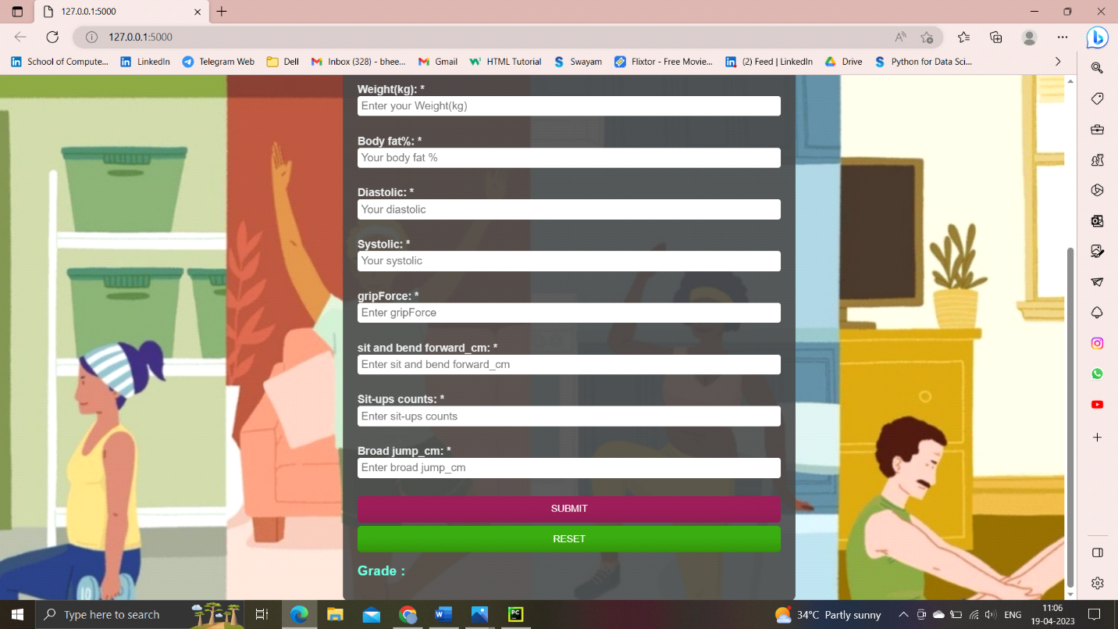

**Fig. 12** User interface and sample result 2



**CHAPTER – 7 CONCLUSION AND FUTURE SCOPE**

**7.1 CONCLUSION**

A person stays happier when he/she is fit and healthy. ​In order to live life healthy, it is essential to exercise for mental and physical development. Thus, exercise is important for the overall growth of a person. It is essential to maintain a balance between work, rest and activities. So, make sure to exercise daily.​

This body performance project is an grading based application that enables the user to keep the required values of their fitness regime. ​

This application is well use full to know the body performance of a person So that we can maintain our body perfectly and we can do the workouts according to the results.

**7.2 FUTURE SCOPE**

In future we can use this system for the analysis of different data sets and adding many symptoms to the data sets. Data mining can be of very good help in deciding the line of treatment to be followed by extracting knowledge from such suitable databases.

**BIBLIOGRAPHY**

* (Pellegrini and Bohn, 2005; see Chapter 5) PHYSICAL FITNESS AND PHYSICAL ACTIVITY: RELATION TO ACADEMIC PERFORMANCE.
* (Shephard et al., 1984; Shephard, 1986; Trudeau and Shephard, 2008) data on youth physical fitness and academic performance have increased access to student-level data on this subject.
* F. Q. Yuan, “Critical issues of applying machine learning to condition monitoring for failure diagnosis,” in 2016 IEEE International Confer-ence on Industrial Engineering and Engineering Management (IEEM),2016, pp. 1903–1907.
* Sibley and Etnier (2003) Physical Activity, Physical Education, and Academic
* Performance​.
* Kramer and colleagues (1999), THE DEVELOPING BRAIN, PHYSICAL ACTIVITY, AND BRAIN HEALTH​
* demonstrate small-to-moderate positive or null associations between physical fitness (Grissom, 2005; Cottrell et al., 2007;)
* Chaddock and colleagues (2010a, b) Effects of Regular Engagement in Physical Activity and Physical Fitness on Brain Structure